### 



Installation Guide

Văn Lang Admissions

# Revision Table

|  |  |  |  |
| --- | --- | --- | --- |
| Author | Date | Reason for changes | Version |
| Hien Nguyen  Khoi Nguyen | 27/05/2017 | Content  Fix Template | 1.0 |
| Hien Nguyen | 28/05/2017 | Update Run MongoDB | 1.1 |

Table of Contents

Revision Table 1

Installation: 3

Node: 3

MongoDB: 8

Redis: 12

Elasticsearch: 16

Run application: 17

Server: 17

Find IP server: 17

Run Mongodb: 19

Set up Server Node: 19

Front-end: 20

Installation Guide

**2 servers:**

**Server 1: Angular2 + Redis + Elasticsearch**

* OS: Window 7 64bit or above
* Ram: 4GB
* Storage: 120GB
* Network: 4MB

**Server 2: Nodejs + MongoDB**

* OS: Window 7 64bit or above
* Ram: 4GB
* Storage: 120GB
* Network: 4MB

# **Installation:**

## **Node:**

* Access URL: <https://nodejs.org/en/>
* Click download v7.10.0.
* Run node-v7.10.0-x64.msi.

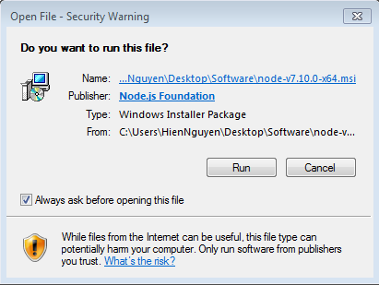

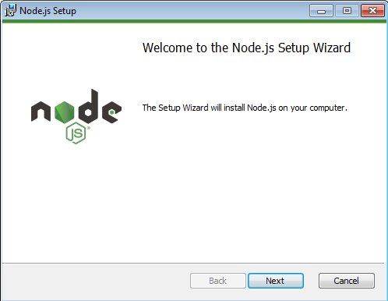

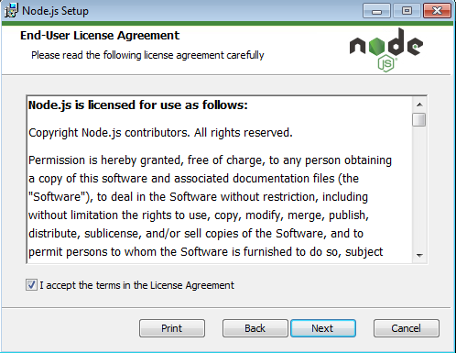

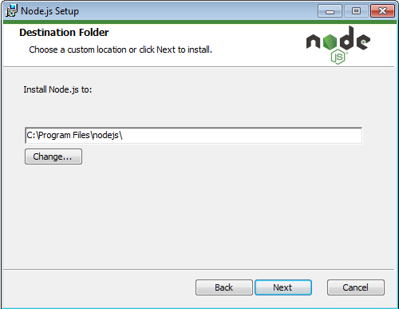

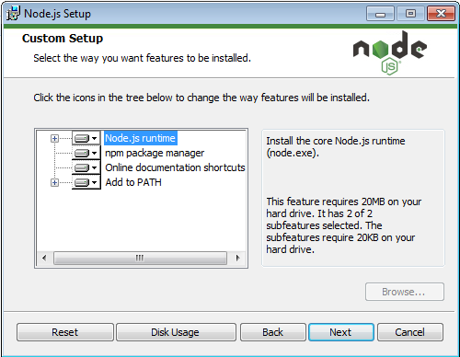

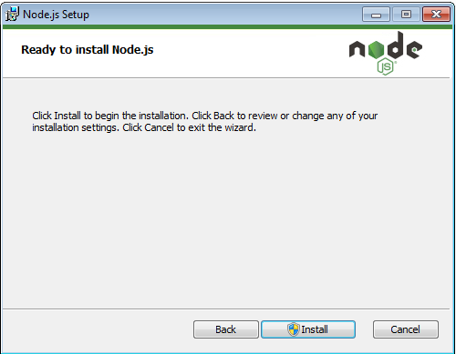

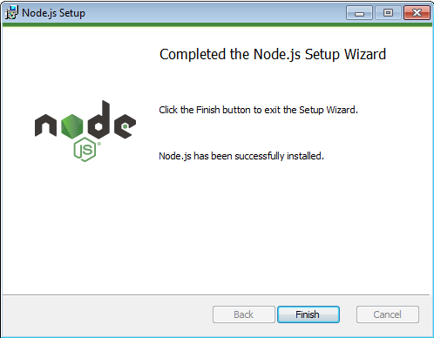

## **MongoDB:**

* Access URL: <https://www.mongodb.com/download-center?jmp=nav#community>
* Click download.
* Run mongodb-win32-x86_64-2008plus-ssl-3.4.4-signed.msi

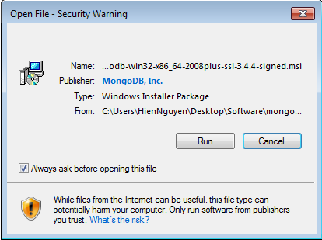

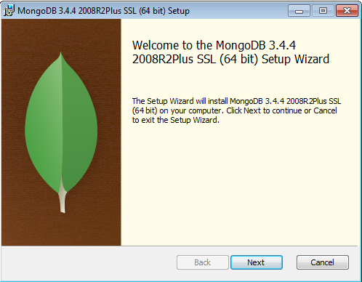

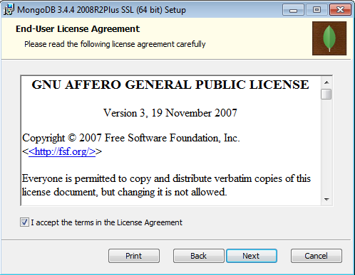

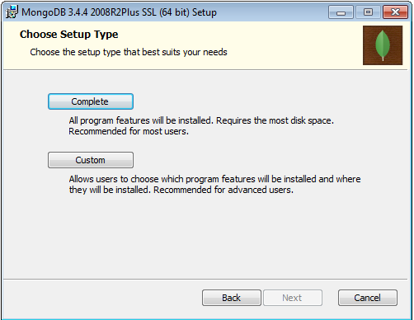

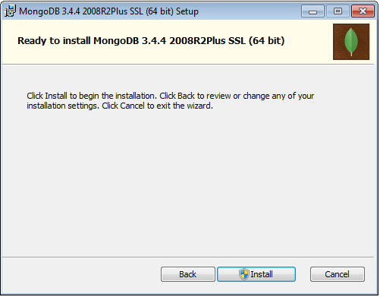

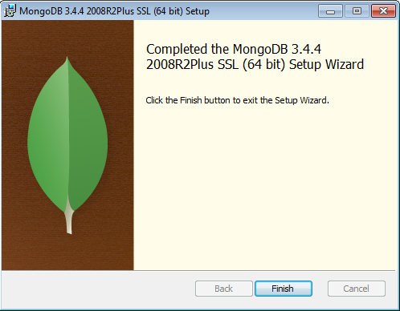

## **Redis:**

* Access URL: <https://www.google.com.vn/url?sa=t&rct=j&q=&esrc=s&source=web&cd=1&sqi=2&ved=0ahUKEwjt8NDaqfvTAhWTQpQKHd87AW4QFgggMAA&url=https%3A%2F%2Fgithub.com%2FMSOpenTech%2Fredis%2Freleases%2Fdownload%2Fwin-3.2.100%2FRedis-x64-3.2.100.msi&usg=AFQjCNHq-i0IrCAvdkG6rsAgEZLxZkiRTw&sig2=b74tGA3gO1zedi5rd7jgLQ&cad=rja>
* Run Redis-x64-3.2.100.msi.

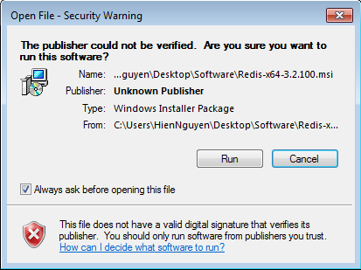

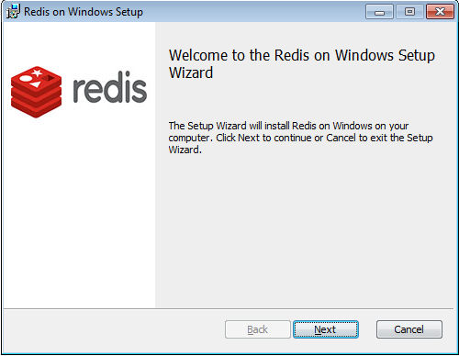

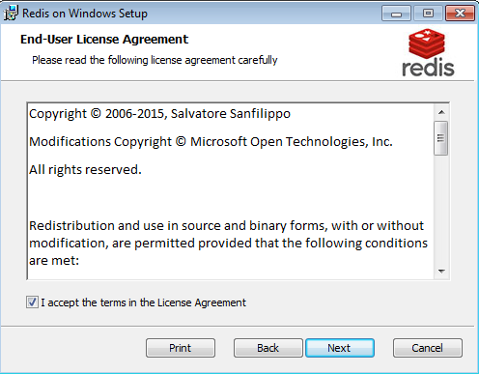

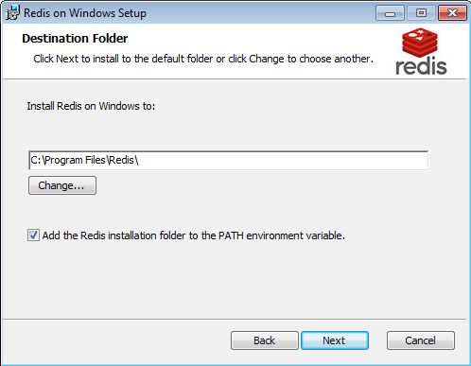

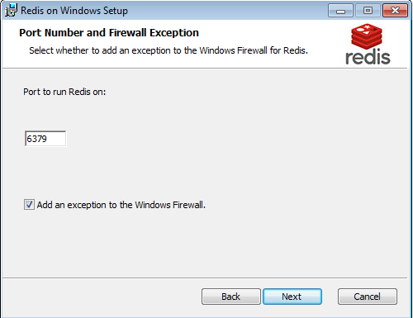

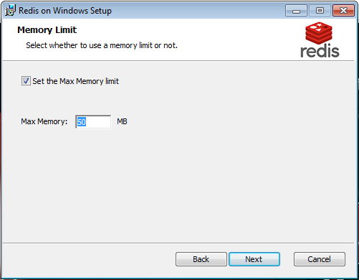

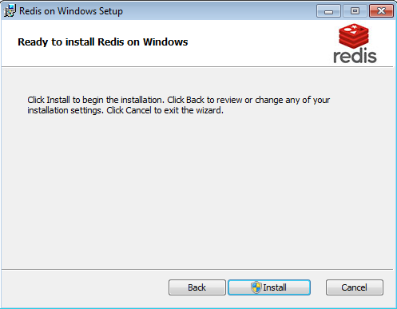

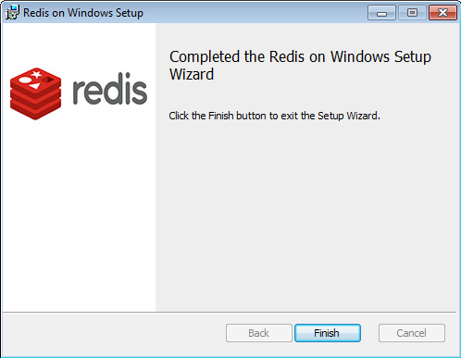

## **Elasticsearch:**

* Access URL: <https://www.elastic.co/downloads/elasticsearch>
* Click download ZIP.
* Unzip file elasticsearch-5.3.0.zip.
* Run file elasticsearch.bat in folder bin.

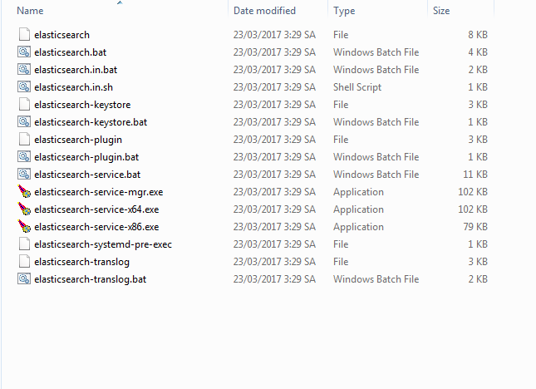

# **Run application:**

## **Server:**

### **Find IP server:**

* Press Window + R.

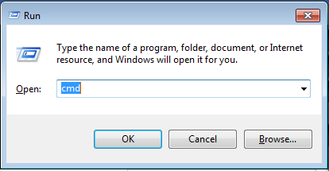

* Type cmd then press enter.

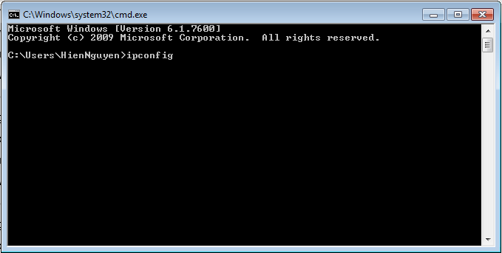

* Type ipconfig then press enter.
* Remember IPv4 Address.

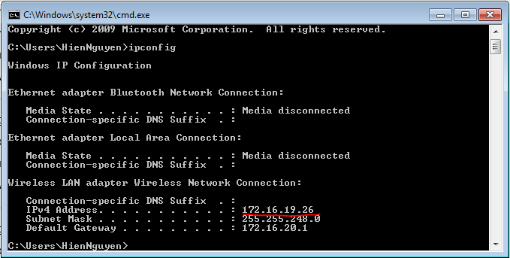

### **Run Mongodb:**

-Open cmd. Go to the directory where your mongodb folder exists and go to a path like C:\MongoDB\Server\3.0\bin. In the bin folder you should have mongodb.exe.

- Type mongod --port 27017 --dbpath "C:\MongoDB\data\db". Then enter.

### **Set up Server Node:**

* Select folder Server.
* Right click file Config.js.

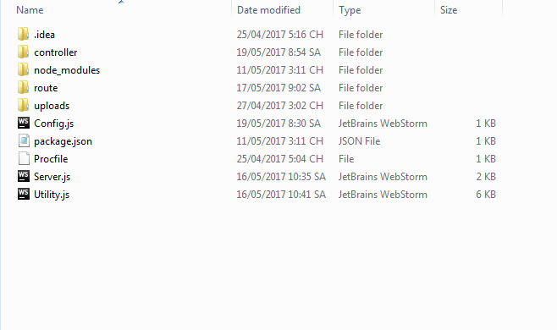

* Choose Open with Notepad.

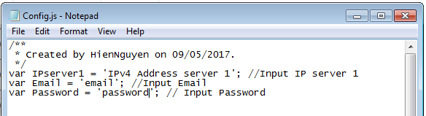

* Replace IPv4 Address server 1 into IPv4 Address in IPserver1 (line 4).
* Add Email and Password in Email and Password (line 5 and line 6).
* Press Ctrl + S.

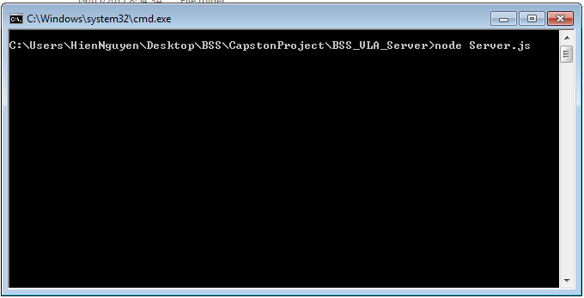

* Then press Ctrl + Shift + Right click white space.
* Choose Open command window here.
* Type node server.js.
* Press enter.

## **Front-end:**

* Select folder FrontEnd.
* Press Ctrl + Shift + Right click this folder.
* Choose Open command window here.
* Type npm start.
* Press enter.